Virtual Catalytic Reactor Laboratory

John L. Falconer and Neil Hendren

Department of Chemical and Biological Engineering

University of Colorado Boulder

Boulder, CO 80309-0596

August 20, 2020

 The text will be double-spaced in final version

**ABSTRACT**

A virtual catalytic reactor laboratory (VCRL) experiment is described. The VCRL allows students to take data for a gas-phase, catalytic reaction and determine kinetic parameters to fit a Langmuir-Hinshelwood rate expression. The VCRL includes an animated equipment diagram from which students select reaction conditions and collect data, equipment descriptions, a start-up procedure, a video of a physical laboratory, screencasts on nonlinear regression, a means to submit answers online, learning goals, and more.

**INTRODUCTION**

A virtual catalytic reactor laboratory (VCRL) experiment was prepared to be used as a replacement for a physical laboratory (PL) or as a longer assignment/project for a kinetics/reaction engineering course. This VCRL can be used in most browsers and is available at <https://virtual-labs.learncheme.com/catalytic-reactor/>. The VCRL aims to imitate a hands-on PL. The goal of the VCRL is to obtain kinetic parameters for a gas-phase, catalytic reaction (A + B --> 2C) by varying the pressure and the inlet molar flow rates of the two reactants and measuring the effluent composition. Nonlinear regression can then be used to obtain the kinetic parameters for a Langmuir-Hinshelwood rate expression.

The VCRL includes an animated equipment diagram from which students select reaction conditions and collect data, a start-up procedure, links to descriptions of system components, a video of a physical catalytic reactor system, screencasts on nonlinear regression, a means to submit answers online, post-lab questions, and learning goals. Students are allocated a fixed amount of funds and each experimental run uses some of those funds. Students, as individuals or part of a group, can create a login so their data is saved; each student or group has a different set of kinetic parameters. Instructors can log in and view their students’ experimental runs and kinetic parameters assigned to them.

**Comparison of virtual and physical laboratories**

Some advantages that virtual laboratories (VLs) over PLs include:

* available at any time and from anywhere
* not time limited. Students can analyze initial results and then plan additional experiments that can be run over multiple days; PLs are time-limited [1]
* able to run experiments that may be too time-consuming to be run in a PL [2, 3]. For example, things that take a few seconds in a VL (furnace reaching a desired temperature, a reactor reaching steady state, a gas chromatograph (GC) analysis) would each take many minutes in a PL. Students can repeat an experiment more easily [13].
* cheaper to purchase and maintain, and VLs almost always work
* able to make phenomena more visible [13]
* safety. For example, VLs can expose students to hazardous techniques that they could not experience otherwise [2]. Different conditions can be tried without damaging equipment.

Because PLs have constraints (safety, logistic, material), instructors often provide directed procedures that limit students’ construction of knowledge so that PLs may not achieve their learning objectives [12]. Thus, studies argued that VLs can adequately replace PLs [5, 14], and VLs allow students to use inquiry practices that might be difficult in PLs [14].

Many studies concluded VLs are more effective than PLs at increasing student learning; studies reported conceptual understanding was as good as or better in VLs. In contrast, some studies concluded that PLs are better, whereas others found no difference [3, 5, 7, 13]. Hernandez-de-Menendez et al. [7] claimed that a consensus does not exist on the impact of VLs on student learning. They claimed that the main advantages of VLs are safety, flexibility (students can perform experiments at any time), and greater diversity of equipment that can be used. Corter et al. [6] concluded that learning outcomes are roughly equivalent no matter which format of lab was used. They stated that the majority of comparative studies concluded that VLs are a good substitute for PLs in teaching concepts and their application. Corter et al. [6] pointed out that the design of the simulation is responsible for the learning differences reported in different studies. The quality of the VLs differ significantly between studies, and students approach VLs differently from the way they approach PLs. Hernandez-de-Menendez et al. [7] claimed that VLs can replace PLs because students have time to complete activities that support deeper learning. They claimed the main disadvantage of VLs is that socialization is not possible [7]. Cooperative learning can improve content achievement and communication skills. However, cooperative learning is possible for VLs through online meetings. Studies suggest tactile information is not needed to develop conceptual knowledge [14]. Instead, manipulation, not physicality, may be important for instruction [13].

Here are a few examples that compared VLs and PLs. In physics, PLs and VLs were equally effective at promoting understanding of concepts, and better than the instruction without PL or VL [4]. In a biology laboratory, fewer students received D's or F's after using VLs [2]. Finkelstein et al. [9] found that VLs can be more effective than PLs. Students who used a simulation on circuits built a real circuit faster than students who used a PL; they also performed 12 percentage points better on the exam. In contrast, Alfred et al. [1] reported cognitive outcomes for a circuits laboratory were the same in a PL and a VL, but students who used a PL could subsequently construct circuits faster [1]. Some studies [8] reported that students had a strong preference for VLs over PLs. Students found it easier to see what was happening in VLs. Holmes and Wieman [10] showed that physics PLs made no difference in performance on final exam questions by comparing performance on questions that had related labs and ones that did not. They attributed this to the lack of decision making by students in the labs.

Studies indicates objectives of PLs and learning [7, 11], and VLs can meet many of these objectives, including: applying instruments and software to make measurements; developing and using models and identifying their strengths and limitations; devising experimental approaches; collecting, analyzing, and interpreting data; evaluating and communicating; working effectively in teams; and behaving with highest ethical standards

**OVERVIEW OF VIRTUAL CATALYTIC REACTOR LABORATORY**

The virtual catalytic reactor laboratory (VCRL) models an exothermic, gas-phase, catalytic reaction (A + B --> 2C) in an isothermal, packed bed reactor. Pressure drop is assumed to be small across the reactor, which is modeled as a plug flow reactor. The goal is to determine the values of k, KA, and KB and their 95% confidence limits for the Langmuir-Hinshelwood rate expression:

$$r=\frac{kP_{A}P_{B}}{{\left(1+K_{A}P_{A}+K_{B}P_{B}\right)}^{2}}$$

where PA and PB are the partial pressures of A and B, k is the rate constant, and KA and KB are adsorption equilibrium constants. The log-in page of the VCRL contains an overview, prerequisites, and the following learning objectives:

* Explain the function of each part of the catalytic reactor system
* Understand how flow rates into a packed-bed reactor (PBR) affect reactant conversion
* Understand the effect of pressure on the rate of a gas-phase reaction
* Efficiently select reaction conditions for PBR measurements
* Explain the reasons experimental conditions were chosen
* Apply nonlinear regression to determine kinetic parameters and their 95% confidence intervals
* Answer questions about catalytic reactor behavior.

The instructor’s login page contains a "how it works" section and sample analysis (results of spreadsheet analysis of data from the VCRL) so instructors know what they should expect from students’ results. It also contains a link to their students’ data, which includes the kinetic parameters assigned to each student (or group) who signed in under the instructor’s name, the students’ calculated values of the kinetic parameters and their confidence intervals, and the amount of funds expended. Each student or group is allocated $10,000, and each experimental run costs $250. Instructors can base part of the student grade on the funds remaining in a student (or group) account. This page contains an option for the instructor to run the simulation as a student. Instructors can request an account by emailing [LearnChemE@gmail.com](mailto:LearnChemE@gmail.com).

The student log-in page contains documentation (Figure 1) that includes how to get started using the VCRL, how to analyze data, and how to submit their kinetic parameters (and confidence intervals). Students can log onto the VCRL under an instructor's name as an individual or as part of a group; they choose a password when they first log on. The simulation stores students’ data so all experiments do not have to be done in one session.

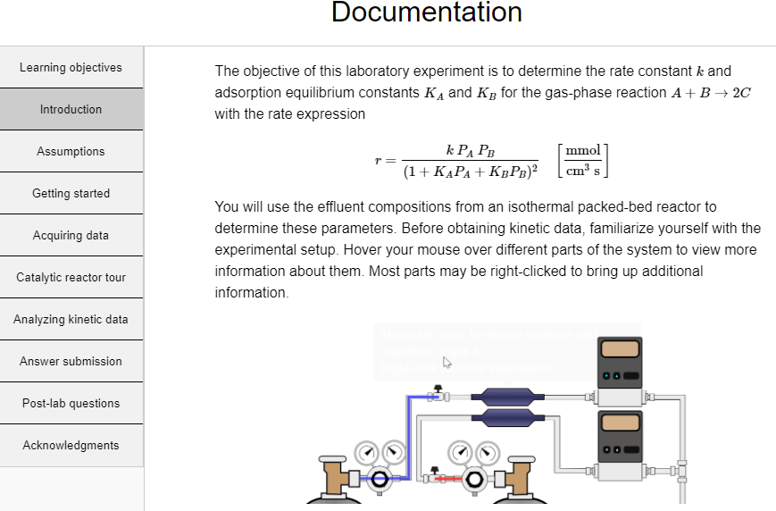

*Figure 1. Documentation page that introduces the VCRL and provides resources for using it. Links to resources are on the left.*

The first time a student logs on, the VCRL selects a temperature and values of the kinetic parameters; each student or group has different parameters. Each time a student logs in, the reactor system in Figure 2 is displayed. Students must start up the equipment each time by clicking “start up reactor”. Each startup costs $150. Clicking “start up reactor” will:

* Open the feed gas valves and close the reactor bypass valve
* Increase the sand reactor temperature to the desired value
* Turn on the GC and inject a calibration mixture
* Allow the system to reach steady state

All aspects of the start-up are much faster than start-up of a PL in order to save time.

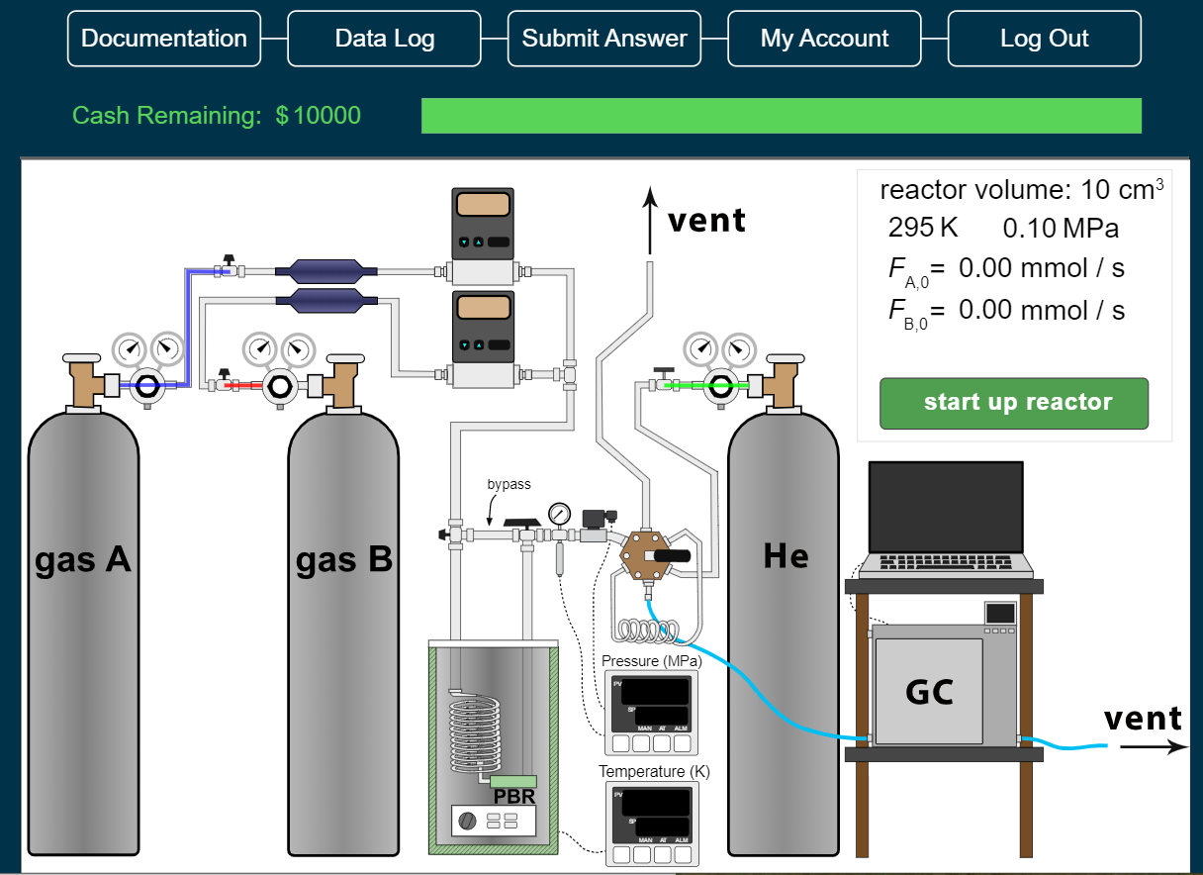

*Figure 2. Main page in VCRL that appears when students log in. The valves to the gas cylinders are closed (the red, blue, and green colors indicate sections of the gas lines that contain gas), the sand batch heater is at room temperature, and the GC is turned off.*

**RUNNING THE VCRL**

Figure 3 shows the VCRL after startup. Tooltips appear when a mouse pointer hovers over a piece of equipment, a right click opens a link that explains more about the equipment. Note that the equipment is not drawn to scale; e.g., the sample loop volume is exaggerated so it is easier to see. A typical sample volume in a PL is 1 cm3. Students take data by selecting a value for the reactor pressure by clicking the pressure transducer read out and typing in a pressure. They select values for the mass flow rates of the two reactants by clicking each mass flow controller (MFC) and typing in a molar flow rate. Students must plan their experiments since the molar flow rates of A and B and the pressure all affect the effluent molar flow rates. The reactor temperature is fixed by the simulation. Operating the VCRL is similar in many ways to operating a corresponding PL. In a PL, the furnace temperature, the pressure, and the MFC values are set on a computer, the multi-selector valve is computer controlled, and the GC results are analyzed by a computer.

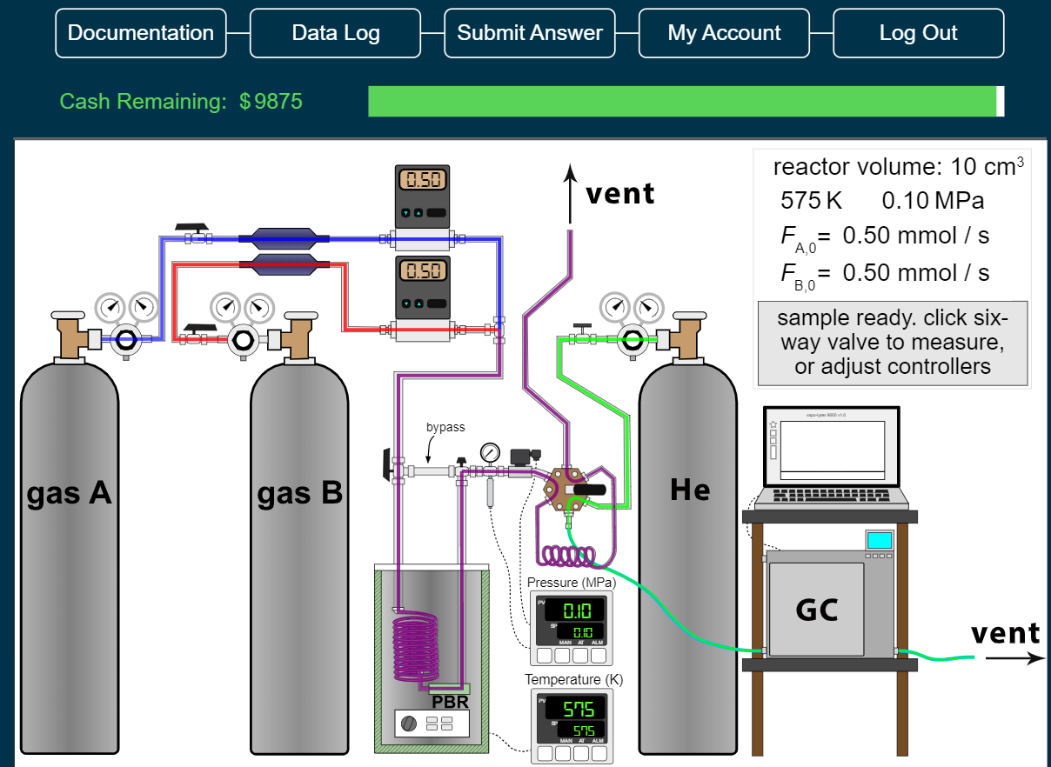

*Figure 3. Main page in VCRL after the system has started up. The gas mixture flowing through the reactor is purple, and the reactor effluent is shown flowing through the sampling loop.*

When a MFC flow rate is changed, the VCRL briefly displays the statement "reaching steady state". Figure 3 shows the system at steady state with the lines for the feed gases (red and blue) mixing to form a purple gas through the preheater coil, the reactor, and the sampling loop and exhausting to the vent. When the multiselector valve is switched by clicking it, the reactor effluent (purple line) goes to the vent as shown in Figure 4, and the green line (He carrier gas) flows through the sample loop. This injects the purple sample volume into the GC and the chromatograph is displayed on the VCRL computer screen. This computer then analyzes the GC output and determines the composition of the effluent stream, which students view by clicking the GC. Data are collected in a CSV file that can be downloaded to a spreadsheet. Students must then click the multiselector valve to move it back to the sampling position to collect the next sample.

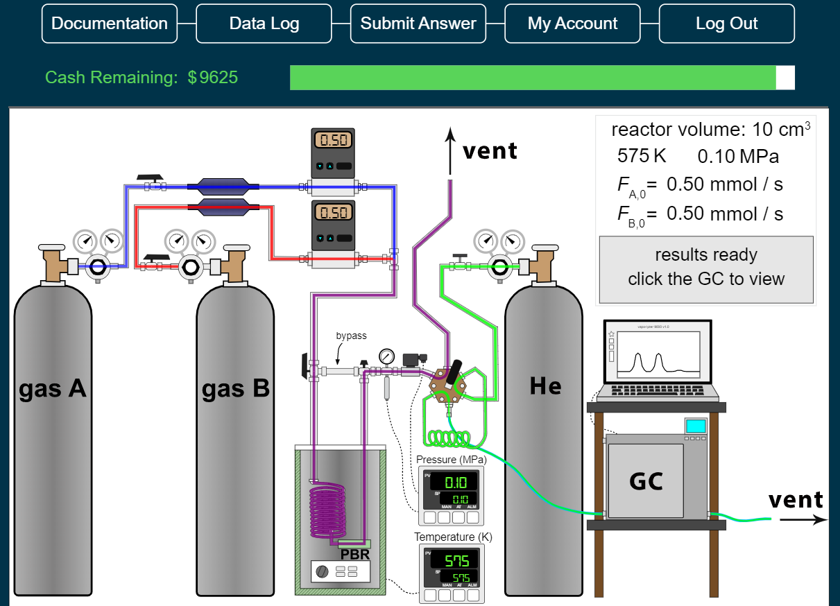

*Figure 4. Main page in VCRL after gas in sample loop had been injected into the GC, and GC analysis results are ready. The reactor effluent is flowing to a vent. The green gas line is helium flowing through the GC.*

Students can work in groups with each student logged onto the VCRL at the same time; they each can run experiments, or one student can run experiments and within a few seconds the data will show up on the data log for the other students to see. Alternatively, one student can log on and share his/her screen with group members using conferencing software (Zoom, Google Meet, GoToMeeting). They can then jointly plan experiments. In many PLs, one student makes changes in the equipment and others record data, make suggestions, and discuss the results.

**DATA ANALYSIS**

Three screencasts in the Documentation explain Langmuir-Hinshelwood kinetics, nonlinear regression, and the approach used to analyze data from a PBR. Four more screencasts demonstrate using nonlinear regression in an Excel spreadsheet to analyze kinetic data. The Excel spreadsheets used in the screencasts are available at <http://www.learncheme.com/student-resources/excel-for-nonlinear-regression>. The spreadsheets solve the differential equation mass balances numerically and apply nonlinear regression to the parameters used in the mass balances.

**ACKNOWLEDGMENTS**

We appreciate financial support from Chevron, the University of Colorado Engineering Excellence Fund, and the Department of Chemical and Biological Engineering. We also appreciate valuable feedback and suggestions from Dr. Scott Rowe, Professor J. Will Medlin, Professor Stephanie Wettstein, Professor David L. Silverstein, Professor Milo D. Koretsky, Professor Margot Vigeant, Mathew Rasmussen, Zachary Blanchetter, and Laura Paz. The nonlinear regression spreadsheets were developed with extensive assistance from Professor David E. Clough. We thank Mathew Rasmussen for making the video of a research laboratory catalytic reactor. The screencasts were processed by Michelle Medlin.

**REFERENCES**

1. Alfred M, Neyens DM, and Gramopadhye AK (2018) Comparing learning outcomes in physical and simulated learning environments. Inter. J. Ergonomics 68: 110-117.

2. Raineri D (2001) Virtual laboratories enhance traditional undergraduate biology laboratories. Biochem. Mol. Biol. Educ., 29(4): 160-162.

3. Sharma S and Ahluwalia PK (2018) Can virtual labs become a new normal? A case study of Millikan's oil drop experiment, Eur. J. Physics, 39, 065804: 1-18. DOI: 10.1088/1361-6404/aada39

4. Zacharia ZC and Olympiou G (2011) Physical versus virtual manipulative experimentation in physics learning. Learn. Instruct. 21(3): 317-331.

5. Altalbe AA (2019) Performance Impact of Simulation-Based Virtual Laboratory on Engineering Students: A Case Study of Australia Virtual System, IEEE ACCESS 7: 177387-177396.

6. Corter JE, Esche SK, Chassapis C, Ma J, and Nickeson JV (2011) Process and learning outcomes from remotely-operated, simulated, and handson student laboratories. Comput. Educ. 57(3): 2054-2067.

7. Hernandez-de-Menendez M, Guevara AV, and Morales-Menendez R (2019) Virtual reality laboratories: a review of experiences. Inter. J. Inter. Design Manufacturing - IJIDEM 13(3): 947-966.

8. Wieman CE, Adams WK, and Perkins KK (2008) PhET: Simulations That Enhance Learning. Science 322(5902): 682–683.

9. Finkelstein ND, Adams WK, Keller CJ, Kohl PB, Perkins KK, Podolefsky NS, Reid S, and LeMaster R (2005), When learning about the real world is better done virtually: A study of substituting computer simulations for laboratory equipment, Phys. Rev. ST-Phys. Educ. Res. 1: 010103-1 – 0101103-8.

10. Holmes NG and Wieman CE (2018) Introductory physics labs: We can do better. Physics Today 71(1): 38-45.

11. Feisel LD and Rosa AJ (2005) The Role of the Laboratory in Undergraduate Engineering Education. J. Engin. Ed. 94(1): 121-130.

12. Nolen SB and Koretsky MD (2018) Affordances of Virtual and Physical Laboratory Projects for Instructional Design: Impacts on Student Engagement. IEEE Trans. Ed. 61(3): 226-233.

13. Zacharia Z (2007) Comparing and combining real and virtual experimentation: An effort to enhance students’ conceptual understanding of electrical circuits. J, Comp. Assist. Learning, 23(2): 120-132.

14. de Jong T, Linn MC and Zacharia ZC (2013), Physical and virtual laboratories in science and engineering education, Science 340(6130): 305–308.